

***SKAPS INDUSTRIES INDIA PVT LTD.***

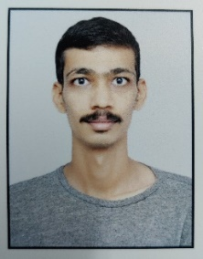

**INTRODUCING A NEW EMPLOYEE**

From: Human Resources  
  
**Re: Joining of Mr. JAY SHAH**   
  
Date: 3rd JULY 2023.  
  
Dear All,

I am pleased to introduce Mr. Jay Shah who has joined SKAPS Industries as a Weaving Incharge in Looms department.

Mr. Jay Shah will be deputed at Mundra Unit-I plant and is currently under training.

Please join me in extending a warm welcome to Jay Shah at SKAPS Industries and get acquainted with our SKAPS culture. We wish him success in the new opportunities and challenges ahead.  
  
  
  
Warm Regards,  
Human Resources.